**DAILY ONLINE ACTIVITIES SUMMARY**

|  |  |  |  |  |  |  |  |
| --- | --- | --- | --- | --- | --- | --- | --- |
| **Date:** | **16/06/2020** | | | | **Name:** | **Imran Khan** | |
| **Sem & Sec** | **8th A** | | | | **USN:** | **4AL16CS040** | |
| **Online Test Summary** | | | | | | | |
| **Subject** | | **BDA** | | | | | |
| **Max. Marks** | | **30** | | **Score** | | **26** | |
| **Certification Course Summary** | | | | | | | |
| **Course** | **HTML5, CSS3 and JavaScript library- jQuery**. | | | | | | |
| **Certificate Provider** | | | **udemy** | **Duration** | | | **10 HOURS** |
| **Coding Challenges** | | | | | | | |
| Problem Statement:  Write a C Program on TLL.. | | | | | | | |
| **Status: Solved** | | | | | | | |
| **Uploaded the report in Github** | | | | **yes** | | | |
| **If yes Repository name** | | | | **Imran040** | | | |
| **Uploaded the report in slack** | | | | **yes** | | | |

Online test details:

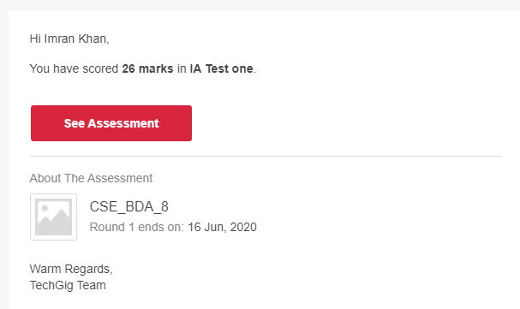

**Certification Course Details**:



**Coding Challenges Details**:

**program1:**

|  |  |  |  |
| --- | --- | --- | --- |
|  | | | |
|  | |
| #include<stdio.h> | |
|  | |  |
|  | | struct SLL; |
|  | | struct TLL { |
|  | | struct TLL *top; |
|  | | struct TLL *bottom; |
|  | | struct SLL *next; |
|  | | }; |
|  | | typedef struct TLL tnode; |
|  | |  |
|  | | typedef struct SLL { |
|  | | char ch; |
|  | | struct SLL *link; |
|  | | }; |
|  | | typedef struct SLL snode; |
|  | |  |
|  | | snode *newnode, *ptr, *prev, *temp; |
|  | | snode *first = NULL, *last = NULL; |
|  | |  |
|  | | tnode *newt, *tlast = NULL, *ttemp; |
|  | |  |
|  | | //--- TLL node--- |
|  | | tnode* create_tnode() |
|  | | { |
|  | | newt = (tnode *)malloc(sizeof(tnode)); |
|  | | if (newt == NULL) |
|  | | { |
|  | | printf("\nMemory was not allocated"); |
|  | | return 0; |
|  | | } |
|  | | else |
|  | | { |
|  | | newt->top = NULL; |
|  | | newt->bottom = NULL; |
|  | | newt->next = NULL; |
|  | | return newt; |
|  | | } |
|  | | } |
|  | |  |
|  | | //---SLL--- |
|  | | snode* create_node(char c) |
|  | | { |
|  | | newnode = (snode *)malloc(sizeof(snode)); |
|  | | if (newnode == NULL) |
|  | | { |
|  | | printf("\nMemory was not allocated"); |
|  | | return 0; |
|  | | } |
|  | | else |
|  | | { |
|  | | newnode->ch = c; |
|  | | newnode->link = NULL; |
|  | | return newnode; |
|  | | } |
|  | | } |
|  | |  |
|  | | //--- insert SLL--- |
|  | | void insert_node_first(char c) |
|  | | { |
|  | |  |
|  | | newnode = create_node(c); |
|  | | if(tlast->next == NULL) |
|  | | tlast->next = newnode; |
|  | |  |
|  | | if (first == last && first == NULL) |
|  | | { |
|  | | first = last = newnode; |
|  | | first->link = NULL; |
|  | | last->link = NULL; |
|  | | } |
|  | | else |
|  | | { |
|  | | temp = first; |
|  | | first = newnode; |
|  | | first->link = temp; |
|  | | } |
|  | |  |
|  | | printf("\n----INSERTED %c TO SLL----", c); |
|  | | } |
|  | |  |
|  | | //---insert TLL--- |
|  | | void insert_Tnode() |
|  | | { |
|  | |  |
|  | | newt = create_tnode(); |
|  | | if (tlast == NULL) |
|  | | { |
|  | | tlast = newt; |
|  | | tlast->next = NULL; |
|  | | tlast->top = NULL; |
|  | | tlast->bottom = NULL; |
|  | | } |
|  | | else |
|  | | { |
|  | | ttemp = tlast; |
|  | | tlast = newt; |
|  | | tlast->next = NULL; |
|  | | tlast->top = ttemp; |
|  | | tlast->bottom = NULL; |
|  | | ttemp->bottom = tlast; |
|  | | } |
|  | | printf("\n----CREATED NEW TLL----"); |
|  | | } |
|  | |  |
|  | | void main() |
|  | | { |
|  | | char s[100], n; |
|  | | int i; |
|  | | scanf("%[^;]s",s); |
|  | |  |
|  | | insert_Tnode(); |
|  | | for(i = 0; s[i] != '\0'; i++) |
|  | | { |
|  | | n = s[i]; |
|  | | if(n == '\n') |
|  | | insert_Tnode(); |
|  | | else |
|  | | insert_node_first(n); |
|  | | } |
|  | | printf("\n%s\n",s); |
|  | | } |